**Steps for authorizing AdWords API:**

* Go to console <https://console.developers.google.com> and log in using the clients google credentials.
* Create a project if already not created.
* ~~Verify that the Invoice API is enabled for the project~~

~~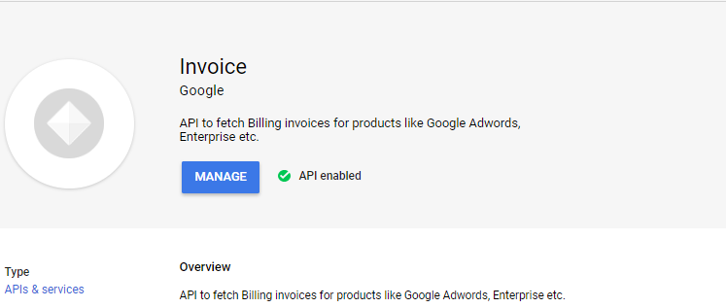~~

[No need for above step anymore, google will automatically authorize it.]

* Create credentials using “OAuth Client ID”

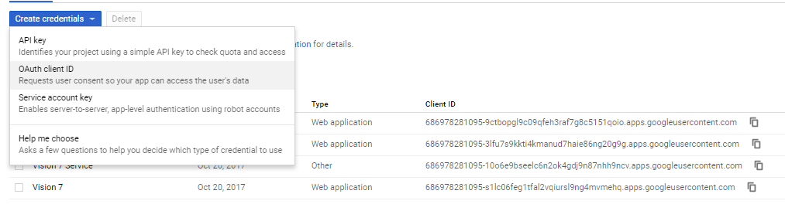

* Following Client ID and Client Secret were generated:
  + **Client ID:** 686978281095-9ctbopgl9c09qfeh3raf7g8c5151qoio.apps.googleusercontent.com
  + **Client Secret:** ZHwmoqHbp0nVC6gGewrI0D15
* After getting the client id and client secret, Goto <https://developers.google.com/oauthplayground>
* On the right-hand side click the settings icon and use the following information:

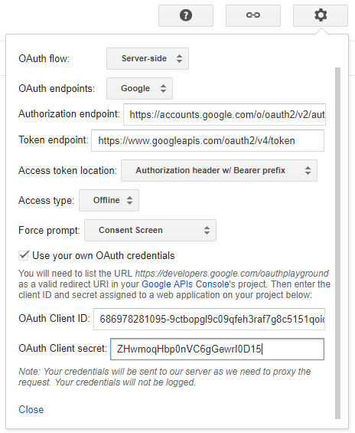

* On the left-hand side enter the scope “https://www.googleapis.com/auth/adwords” and press “Authorize APIs”.

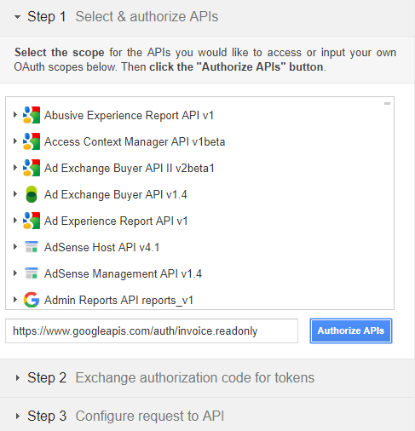

* This will redirect to sign in to account again, go ahead and do that.
* After successful authorization you will be provided with the “Authorization Code” which is then used to exchange for Tokens

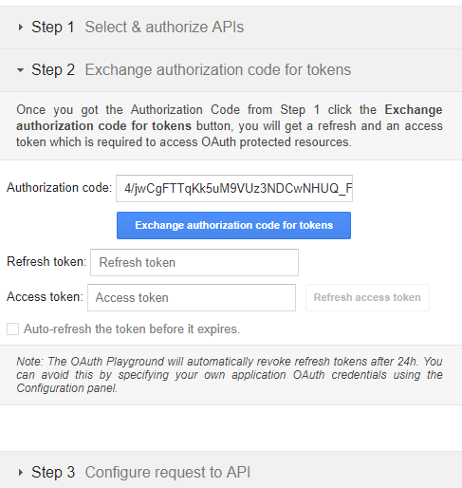

* Press “Exchange authorization code for tokens” for getting refresh token and access token.
* Access token is not used as it is generated every time during authentication process but take note of the refresh token.

**Steps for authorizing invoice API:**

* Go to console <https://console.developers.google.com> and log in using the client’s google credentials.
* Create a project if already not created.
* ~~Verify that the Invoice API is enabled for the project~~



[No need for above step anymore, google will automatically authorize it.]

* I created credentials using “OAuth Client ID”



* Following Client ID and Client Secret were generated:
  + **Client ID:** 686978281095-9ctbopgl9c09qfeh3raf7g8c5151qoio.apps.googleusercontent.com
  + **Client Secret:** ZHwmoqHbp0nVC6gGewrI0D15
* After getting the client id and client secret, Goto <https://developers.google.com/oauthplayground>
* On the right-hand side click the settings icon and use the following information:



* On the left-hand side enter the scope “<https://www.googleapis.com/auth/invoice.readonly>” and press “Authorize APIs”.



* This will redirect to sign in to account again, go ahead and do that.
* After successful authorization you will be provided with the “Authorization Code” which is then used to exchange for Tokens



* Press “Exchange authorization code for tokens” for getting refresh token and access token.
* Access token is not used as it is generated every time during authentication process but take note of the refresh token